CA – Business Reqiurements

Cassablanca Holiday Centre

1.

|  |  |  |  |  |
| --- | --- | --- | --- | --- |
|  |  | Helpful |  | Harmful |
| Internal |  | Strengths |  | Weaknesses |
|  |  | Well established in European travel agencies |  | Poor business procudures. |
|  |  | Prime Location, 5km from casablanca and 1km from the beach |  | Complicated IT system, which creates hassle for employee and guess alike. |
|  |  | All communication within the centre  is in English |  | Excel system developed by a book keeper whom is no longer employed, which can create troubles when updating or wanting to change the system |
|  |  | Overall high quality |  | Complicated and outdated booking system, of them checking room availability after customer asks, should be able to see whether rooms are available beforehand. |
|  |  | One payment for both food and sports centres |  | Secretary of the establishment does not seem to have a fast way of checking what is booked and what is not. |
|  |  | Wide range of sports available |  | Secretary has to check check and update Excel system manually, daily. |
|  |  |  |  | Outdated system of checking passport information, and guest identification. |
|  |  |  |  | Key hand out should be something that is done by an IT system, and governed by an IT system, so you always know how many keys you have active and how many you need back at the end of a stay. Possible keycard upgrade. |
|  |  |  |  | Payment of instructors should be possible to be added on to your room bill, to allow for less hassle for the customer. |
|  |  |  |  | Handball and Volleyball could maybe be restructured to make an easier way to know if you are doing something in the hour or not. |
|  |  |  |  | When you go on a booking, in the IT system you should instantly be able to see whether it is booked or not, and you should be able to see on every single computer which activity has been booked, when, and by who.  One payment for both food and sports centres |
|  |  |  |  |  |
| External |  | Opportunities |  | Threats |

2.

The overall goal is to allow customers to sign up to activities without the staffs help in most cases, and to allow the staff to quickly check credentials, identification, bookings, etc. without spending time talking to each other, and instead just quickly checking it on the computer. If they are allowed to do so, it would mean less work for everyone, and that is overall beneficial.

The specific goal is to put a new IT-system in place, that is able to streamline most of the processes of signing up and booking different activities and rooms in the centre, because currently the processes are slow and un-optimized, which means it is both hard for the customer and the employee to do anything quickly, within the system. Optimizing the overall processes in the facilities allows your employees to spend more time on keeping your customers satisfied, instead of spending time trying to figure out some processes within the sign up system. Another feature that could be put in place is key cards instead of actual keys, that allow the secretary to see how many key cards are currently in use for each room, and it does not allow for confusion of lost keys.

The way to optimize the process would be to implement an overall system that can be entered into

By all the computers in the facility, to check bookings of personal trainers and sports rooms. The

Secretaries and managers also need a system; wherein they can enter credentials, instantly upload

Photos and identification to a database, to allow the secretaries to instantly check, when the family

Checks in at the counter, whether they have booked properly. A user interface, with a login and

Password, possibly room number and a self-chosen password at the check-in would most likely be

The easiest way to maintain knowledge of your own bookings, and the make your own bookings.

Yet another thing could be to create an app for smartphones that could hold all the information on the timetables of the activities and personal trainers within the facility to make it easier to sign up for activities and personal training, but that is more a long term goal, the main goal is to streamline the currently outdated sign up and booking process.

3.

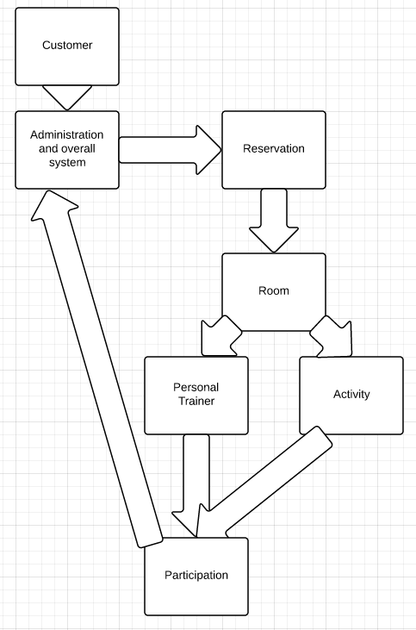

4.

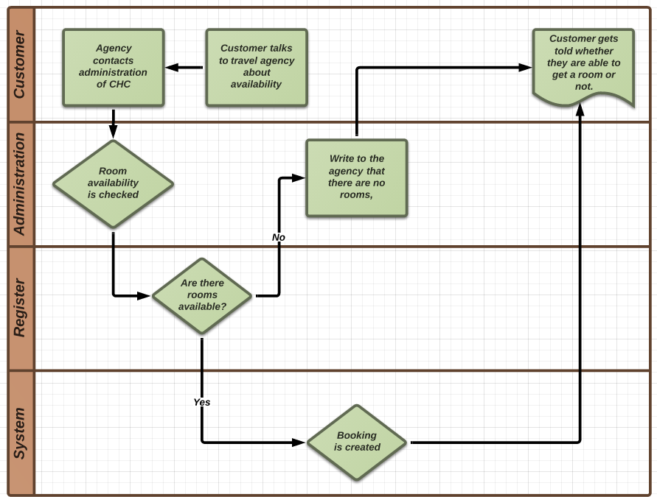

5.

The new IT-system should be able to:

* Allow the secretaries, managers, travel agencies and customers to instantly see what, and how many, rooms are free within the centre.
* Allow customers to book rooms on a website.
* Allow customers to see which activities are already booked, and which are free inside the centres IT-system
* Allow the customers to see which instructors are free.
* Allow the customers to settle debates, such as who booked first and there should be zero double bookings.
* Allow the customers to see immediately how many people have signed up for volleyball or team handball on the system, to see when they might be able to play against others. Maybe allow a comment to be left, what kind of match other people are looking for; casual fun, competitive, etc.
* Allow the customer to check in with a user name, such as their room number, and then a self-chosen password, created at the check-in of the hotel, to keep check of bookings.

6.

